DRAFT

AGREEMENT AMONG THE PARTICIPATING STATES OF THE INDIAN OCEAN COMMISSION REGIONAL FISHERIES SURVEILLANCE PLAN FOR THE ESTABLISHMENT OF REGIONAL MECHANISMS FOR THE EXCHANGE OF FISHERIES INFORMATION FOR THE PURPOSE OF MONITORING CONTROL AND SURVEILLANCE (MCS)

The Parties to this Agreement,

HAVING REGARD to the United Nations Convention on the Law of the Sea of 10 December 1982, the 1995 United Nations Agreement for the Implementation of the Provisions of the United Nations Convention on the Law of the Sea relating to the Conservation and Management of Straddling Fish Stocks and Highly Migratory Fish Stocks of 4 December 1995, the 1995 FAO Code of Conduct for Responsible Fisheries and in particular Article 7 on Fisheries Management and the 2001 FAO International Plan of Action to Prevent, Deter and Eliminate Illegal, Unreported and Unregulated Fishing;

HAVING REGARD to the relevant resolutions of the Indian Ocean Tuna Commission and the Southern Indian Ocean Fisheries Agreement;

CONSIDERING the Indian Ocean Commission (IOC) Ministerial Declaration for Combating Illegal, Unreported and Unregulated (IUU) Fishing in the South West Indian Ocean Region of 23 January 2007 and the commitment to establish the IOC Regional Fisheries Surveillance Plan (PRSP);

CONSIDERING the Administrative Arrangements entered into by each Participating state in the 2007 Declaration of the Ministerial Conference for Combating Illegal, Unreported and Unregulated (IUU) Fisheries in the Southwest Indian Ocean with the Secretariat of the Indian Ocean Commission (IOC);

CONSIDERING THE 2014 Memorandum of Understanding to establish a Regional Monitoring Scheme for Fishing Activities and Data Sharing among the Member States of the Indian Ocean Commission, cooperating for the creation of a Regional Monitoring Scheme for Fishing Activities and Data Sharing and its Confidentiality, this Agreement shall replace the 2014 MOU.

CONSIDERING the Protocol on Fisheries signed by Southern African Development Community (SADC) Ministers responsible for fisheries on 14 August 2001 and the Statement of Commitment to Combat Illegal, Unreported and Unregulated (IUU) Fishing signed by SADC Ministers responsible for marine fisheries on 04th July 2008;

CONSIDERING the commitment of each State to ensure by its own means sufficient capacity to the exchange and sharing of fisheries MCS information in a near real time period;

RECALLING the endorsement on 21st October 2011 by the Permanent Liaison Officers of the IOC member States of a recommendation to enlarge the activities of the PRSP Regional Coordinating Unit to neighbouring coastal States; ;

RECALLING the recommendations of the Ministerial Declaration of PRSP participating States’ Fisheries Ministers of 21st July 2017;

ACKNOWLEDGING the concerns raised by the Parties regarding the ongoing problem of illegal fishing activities in the adjacent marine areas, in violation of applicable national, regional and international laws and obligations;

RECOGNIZING the need to establish a regional mechanism to exchange fisheries information for the purpose of monitoring, control and surveillance among the Parties;

HAVE AGREED as follows,

Article 1 Use of terms
For the purposes of this Agreement:

“Automatic Identification System” (AIS) means an automatic tracking system used on ships for identifying and locating vessels by electronically exchanging data with other ships, AIS base stations and satellites;
“Authorization to Fish” means an authorization issued by a flag State to its domestic fishing vessels engage in fishing or fishing related activities in areas beyond its national Jurisdiction;
“data processing” means all operations concerning data by human or other means and processes or by using algorithms to extract and analyse the information needed to monitor fishing operations, analyse any risks pertaining to the information and detect suspicious fishing operations;
"exclusive economic zone” (EEZ) refers to the EEZ declared by each Party in its national legislation;
“fisheries information” includes any information or data in any medium, including electronic, documented, reproduced or other that may be relevant, directly or indirectly, for any purpose of fisheries management or MCS at national, regional or international levels;
‘’exchange of information’’ or “information exchange” refers to any communication of fisheries information for the purpose of fisheries MCS or management, and for providing, receiving or collecting strategic intelligence for fisheries MCS and includes sharing of information;
"Fisheries Monitoring Centre” (FMC) refers to a Party’s institutional and administrative structure that is given operational powers, duties and responsibilities for fisheries monitoring, control and surveillance;
“fishing” means searching for, attracting, locating, catching, taking or harvesting fish or any activity which can reasonably be expected to result in the attracting, locating, catching, taking or harvesting of fish;
“fishing related activity” means any operation in support of, or in preparation for, fishing, including the landing, packaging, processing, transhipping or transporting of fish that have not been previously landed at a port, as well as the provisioning of personnel, fuel, gear and other supplies at sea;
fishing vessel" means any vessel designed or equipped to search for, attract, locate, catch, take or harvest fish or any activity which can reasonably be expected to result in attracting, locating, catching, taking or harvesting fish and includes vessels used for fishing related activities; ;
‘Indian Ocean Commission” (IOC) means the Indian Ocean Commission created in 1982 by the Port-Louis Declaration and established in 1984 by the General Agreement of Victoria;
“Monitoring Control and Surveillance” (MCS) refers to monitoring, control, surveillance and enforcement of fishing and fishing related activities;
“Participating State” refers to a State or regional economic integration organization that signed the 2007 Declaration of the Ministerial Conference for Combating Illegal, Unreported and Unregulated (IUU) Fisheries in the Southwest Indian Ocean, and includes Comoros, France, Mauritius, Madagascar and Seychelles, as members of the Indian Ocean Commission, and the European Commission;
“Partner” refers to a regional or international organization that has become a partner pursuant to Article 4.3;
“Party” means a Participating State that has consented to be bound by this Agreement and for which this Agreement is in force, and includes any Partner that has agreed to be bound by this Agreement in accordance with Article 4.3;
“Standard Real-time Fisheries Information Hub” (StaRFISH) means the internet tool operated by the IOC-PRSP for storing, aggregation and sharing of data and information;
“Suspicious fishing operation” refers to the behaviour of one or more fishing vessel which indicates [or raise reasonable inference of] non-compliance with applicable national laws, conservation and management measures of regional fisheries management organizations or international obligations;
“System Information Géographique Maritime ‘’ (SIGMA) means, the IOC system for the purpose of sharing fisheries information from VMS, AIS, satellite imagery and oceanographic data;
"Vessel Monitoring System” (VMS) refers to a system used for monitoring the position of fishing vessels based on an embedded device that is capable of transmitting satellite data on the position and course of the vessel to a coastal State and the flag State, in accordance with protocols which may provide for transmission through the flag State or shipowner directly to a coastal State.
Article 2
Objective and regional cooperation framework

- The objective of this Agreement is to establish a regional framework among the Parties to enhance fisheries information exchange for the purpose of regional cooperation in fisheries MCS in the South West Indian Ocean region that provides a web-based fisheries information exchange system with a common centralised database that aims to maintain a proper record of operational activities and share MCS fisheries information, while observing and respecting the national sovereignty and territorial integrity of each Party.

- This Agreement aims specifically to:

  - strengthen the Parties’ knowledge of fisheries information and fisheries-related crime through a recognised information exchange mechanism in the South West Indian Ocean region;
  - control and monitor fisheries activities in real-time or near-real-time to enhance national and regional MCS management and inform risk assessment and decision making;
  - build the capacities of the Parties for increased knowledge about MCS technology and better use of the MCS fisheries information;
  - enhance the culture of sharing and exchanging fisheries information for the purpose MCS in the South West Indian Ocean region;
  - enhance and ensure the sharing and exchange of MCS fisheries information among the national Fisheries Monitoring Centres (FMCs) and with [through the] IOC. and IOC.

Article 3
Application

This Agreement shall apply to fisheries information related to the Zone of Cooperation described in Annex I and to flag vessels of Parties in areas beyond their national jurisdiction.

Article 4
Parties and partners to this agreement

- The States and regional economic integration organization participating in the IOC-PRSP shall be eligible to sign this Agreement in accordance with Article 14(1).
- Other cooperating States from the Eastern Africa, Southern Africa and Indian Ocean region shall be eligible to accede to this Agreement in accordance with Article 14(2) after it enters into force in accordance with Article15 and shall become Parties to this Agreement upon the entry into force of the accession.
- Cooperative partnership arrangements may be made for the implementation of this Agreement with regional organizations or international organizations with a mandate for fisheries management, fisheries MCS or maritime safety.
- The Parties shall cooperate in good faith in implementing the provisions of this Agreement.
Article 5
General Principles

In order to promote the effective implementation of this Agreement and with due regard to appropriate confidentiality requirements, Parties shall exercise their duties and responsibilities consistent with the following principles:

- the information exchange mechanism shall be effectively used to the greatest extent possible, including for cooperation in combating illegal, unreported and unregulated fishing, strengthening sustainable fisheries management, supporting legal fisheries operations and ensuring a cost reduction for information gathering;
- complete and accurate data and information under the scope of this Agreement shall be required, collected and shared in a timely manner;
- requirements under this Agreement relating to security, access to information and confidentiality shall be implemented in accordance with the highest possible standards;
- sufficient human, institutional and technological capacity shall be made available for efficiently implementing this Agreement; and
- effective cooperation shall be pursued with other States and regional and intergovernmental organizations in matters under the scope of this Agreement.

Article 6
Responsibilities of the Parties

1. The Parties shall commit to implement the StaRFISH and SIGMA information platform for the purpose of fisheries information exchange;
2. The Parties shall, wherever possible exchange information through the use of agreed secure protocols, between their MCS information systems and the sub-regional VMS and StaRFISH platforms;
3. The Parties shall ensure their legislation does not obstruct the sharing of information in order to fulfil the objectives of this Agreement;
4. Each Party shall ensure the necessary capacity to exchange fisheries information for the purpose MCS in real time or near real time;
5. The Parties shall guarantee compliance with the confidentiality requirements on the access and use of the fisheries information exchanged provided in Article 10 of this Agreement;
6. Each Party shall take all necessary technical measures to protect confidential data against unauthorized disclosure or access;
7. The Parties shall ensure that the existing national structures and installations are maintained in constant operational condition in order to collect, process and protect fisheries information that is exchanged under this Agreement; and
8. Each Party shall appoint one or two administrators to implement this Agreement, based on their national MCS structure.

Article 7
Fisheries information exchange

The Parties and Partners shall collect and exchange the fisheries information required in Annex II, in accordance with their applicable national legislation.

Article 8
Location of the regional server and data security

- The regional server and all associated infrastructure for the information sharing systems shall be located within the headquarters of the Indian Ocean Commission in Mauritius which benefits from the privileges and immunities protection provided to the Headquarters Establishment Agreement signed with Mauritius in 1989.

- Data security shall be ensured through:

- a permanently available secure Internet connection which allows data to be secured and data access safeguarded during communication;
- HTTPS Protocol and data sharing, which will enable a secure permanent location between a client and server, guarantee the identity of the server that supports the encryption of information in transit, be almost synchronous and not require additional hardware; and
- storage of data on server based on the quality/reliability of the storage medium and the quality/reliability of access control to that server.

Article 9
Access to fisheries information

The Parties agree that:

- access to the exchanged fisheries information and its use shall be strictly reserved for:
- persons authorized by their Competent Authority to know and use the information;
- persons designated as National Authorities of Parties;
- persons in charge of fisheries MCS; and
- authorised IOC personnel who possess the relevant signed certificate of confidentiality;
- access to the fisheries information database is available only to Parties contributing towards the exchange and sharing of such information;
- for access to the server, the user name shall have sufficiently long passwords to ensure a high level of security;
- the system shall be housed within the PRSP technical unit, the regional coordination unit;
- the users of the fisheries information database shall be:
- authorized members of staff of the FMC;
- authorized IOC MCS personnel who possess the relevant signed certificate of confidentiality;
- managers of Parties’ observer programs; and
- through a process of acceptance to be agreed among parties, authorized compliance personnel of a regional fisheries management organisation and other regional fisheries MCS and maritime security organisations.
- the users shall have access to the fisheries data described in Article 6 to view and/or input data depending on their user rights; and
- the administrators shall have access to the technical data, can make use of the administrative module and are the code list editors that:
- entails fish species, country codes and associated information;
- manages the respective country and organisation lists and other associated elements such as ports and fisheries zones; and
- manages the users and groups.

Article 10
Procedures for the exchange and sharing of fisheries information

- The exchange and sharing of fisheries information shall primarily take place through the StaRFISH and SIGMA and/or verbally, visually in writing, or in any other secure form.
- The reception by IOC and the Parties of the information sent by the Parties through StaRFISH and SIGMA shall take place securely and under encryption via electronic means, and be accessible only to authorized personnel holding a certificate of confidentiality signed by a relevant user or administrator.
- The parties shall exchange VMS data in accordance with the protocol in Annex XXX.

Article 11
Information protection and confidentiality measures

- The information exchanged or shared under this Agreement shall at no time be freely accessible to the public or commercial domain, and shall not be exchanged or shared except in accordance with this Agreement. .
- The information processed within the PRSP regional database using StaRFISH or other tools shall be confidential and shall be used for non-commercial purposes only, such as fisheries management, monitoring control and surveillance, fisheries-related crime and maritime safety and security.
- Information may be released to non-state third parties, and shall be used by them exclusively in accordance with Article 12.
- A confidentiality agreement shall be signed by all users, including persons designated to manage the servers [IT infrastructures].
- Parties shall take all necessary measures, [including adoption of Non-Disclosure Agreements to prevent the disclosure of information.
- In the event of actual or suspected loss or disclosure of the shared information and it is within the effective non-releasable window, an inquiry shall be ordered. IOC and the Parties shall keep one another mutually informed of the progress and conclusions of the inquiry.

Article 12
Release of confidential information

Notwithstanding the provisions in Article 11, confidential information may be released (note criteria if any) to (xxxx) in the event of (e.g. an official investigation or request for purposes related to any legal process or matter by designated authorities that may be agreed by the Parties (e.g. national or international police, mandated defence, force, judicial, legal, fisheries enforcement or related authorities) or otherwise upon agreement of all Parties, providing:

- no release or transmission of information shall be made except in confidence to such an authority; and
- at the request of such an authority of a Party or non-party to this Agreement , only the information relevant to the investigation shall be transmitted following consent by:
- the Party or Partner that exchanged or shared the information through the regional servers StarFISH, SIGMA or other as may be agreed by the Parties; and
- the State that carried out the operation, inspection, observation and/or investigation.

Article 13
Secretariat services and financial arrangements

- There shall be no additional cost for the Participating states for the implementation and maintenance of the fisheries information exchange system.
- Parties shall use, inter alia, the information exchange system [provided by the IOC], which will provide secretariat services for the information exchange system and, with the support of cooperative programs in marine fisheries, will:
  - support the cost of:
- the acquisition and upgrade of the server;
- HTTPS for securing information and data exchange;
- the continuous development and technical support of the StaRFISH software;
  - provide an air-conditioned computer room, connected to electrical networks and a reliable internet connection;
  - ensure maintenance of the server and the room;
  - ensure maintenance of the computer system;
  - manage the database and its regular maintenance;
  - take all the local protective measure against intrusions and restrictions on access control measures; and
  - support capacity building for administrators and users.

Article 14
Signature and accession

- This Agreement shall be open for signature by States and the regional economic integration organization referred to in Article 4(1).
- After this Agreement enters into force in accordance with Article 15, it shall be open for accession by all States referred to in Article 4(2) which have submitted detailed information on:
  - the compatibility of its national legislation and any fisheries access agreements in force with the requirements for the exchange of fisheries information under this Agreement;
  - its national MCS scheme, including the effectiveness of its operation and its technical compatibility with the exchange and sharing of fisheries information in accordance with this Agreement;
  - its ability to implement this Agreement, and in particular the requirements of confidentiality in Article 10 and of restriction of use and access to shared data in Article 11; and
  - the list of client computers authorized to connect to the regional information database,
and where the Parties have unanimously decided to permit accession.

Article 15
Entry into force and consequential termination

- This Agreement shall enter into force on the date of its signature by the XX State described in Article 4(1).
- After entry into force, States described in Articles 4(2) may accede to the Agreement in accordance with procedures described in Article 14(2) and shall deposit their instruments of accession with the depositary.
- Upon entry into force, this Agreement shall replace the 2014 Memorandum of Understanding among the Member States of the Indian Ocean Commission on a Regional Monitoring Scheme for Fishing Activities and Data Sharing and its Confidentiality.
Article 16
Amendments

- Any Party may, at any time after the entry into force of this Agreement propose amendments to this Agreement and its Annexes by communicating the text of its proposal to the Depositary, which shall promptly circulate any such proposal to all Parties.
- Amendments shall be adopted during a meeting of the States Parties, by consensus of the Parties represented.
- Amendment shall enter into force thirty (30) days after the Depositary has received instruments of acceptance or approval from all Parties.

Article 17
Interpretation

In the event of doubts or disputes between two or more Parties arising from the interpretation or implementation of this Agreement and/or its Annexes, the Parties shall consult in order to settle the dispute by means of negotiations or any other peaceful means of their choosing.

Article 18
Compliance and effective implementation

Each Party shall take all appropriate measures commensurate with its resources, in accordance with its obligations, and with current international law in order to comply and ensure compliance with this Agreement.

Article 19
Withdrawal and suspension

- [In the event of any failure to implement this Agreement, particularly in relation to rules of confidentiality, usage restrictions, data access, updating the database and ensuring the maintenance of infrastructure, the Parties shall be informed immediately in writing. This Agreement may be fully or partially suspended, including in the event of serious breaches of the principles or provisions contained herein.]
- [In the event of non-settlement of a dispute or reported breach of this Agreement, , this Agreement may be terminated by one or more Parties that notify their intentions in writing at least three (3) months prior to termination taking effect. Upon receipt of the notification, the Parties shall carry out consultations in order to resolve any disputes amicably within the notice period of three months or urgently if the conditions of confidentiality are affected.]
- Regardless of any case of failings in the implementation of this Agreement or of any dispute, any Party may withdraw from this Agreement. Withdrawal shall take effect twelve (12) months after receipt, by the Depositary, of the notification of withdrawal.
- This Agreement shall continue to apply after withdrawal in relation to any administrative or judicial proceedings arising from measures taken under this Agreement concerning the withdrawing Party.

Article 20
Protective measures of suspension

- Any Party that has clear proof of a breach of confidentiality by another Party in violation of this Agreement, and which on reasonable grounds could foreseeably undermine the entire fisheries information exchange system, shall notify in writing all other Parties and IOC of the breach and call for an immediate suspension of information exchanges between the Party concerned and the IOC in order to safeguard the regional information exchange system.
- Upon agreement by consensus or a majority of Parties, such information exchanges between the Party concerned and the IOC shall be immediately suspended until such time as the violation has been investigated and Parties agree that it is secure to resume them.

Article 21
Reservations and exceptions

Each State Party may, in accordance with its constitution and legislation and in compliance with international law, make reservations to this Agreement unless they are incompatible with its objectives.
Article 22
Relation to other agreements

- ​This Agreement shall not alter the rights and obligations of Parties​ which arise from other agreements compatible with this Agreement and which do​ not affect the enjoyment by other Parties of their rights or the​ performance of their obligations under this Agreement.
- Two or more Parties may conclude agreements modifying or suspending​ the operation of provisions of this Agreement, applicable solely to the​ relations between them, provided that such agreements do not relate to a​ provision derogation from which is incompatible with the effective execution of​ the object and purpose of this Agreement
Article 23
Depositary

- The original of this Agreement shall be deposited with the Indian Ocean Commission, which shall serve as the Depositary.
- The Depositary shall transmit certified copies of the Agreement to all signatories.

ANNEX I

ZONE OF COOPERATION

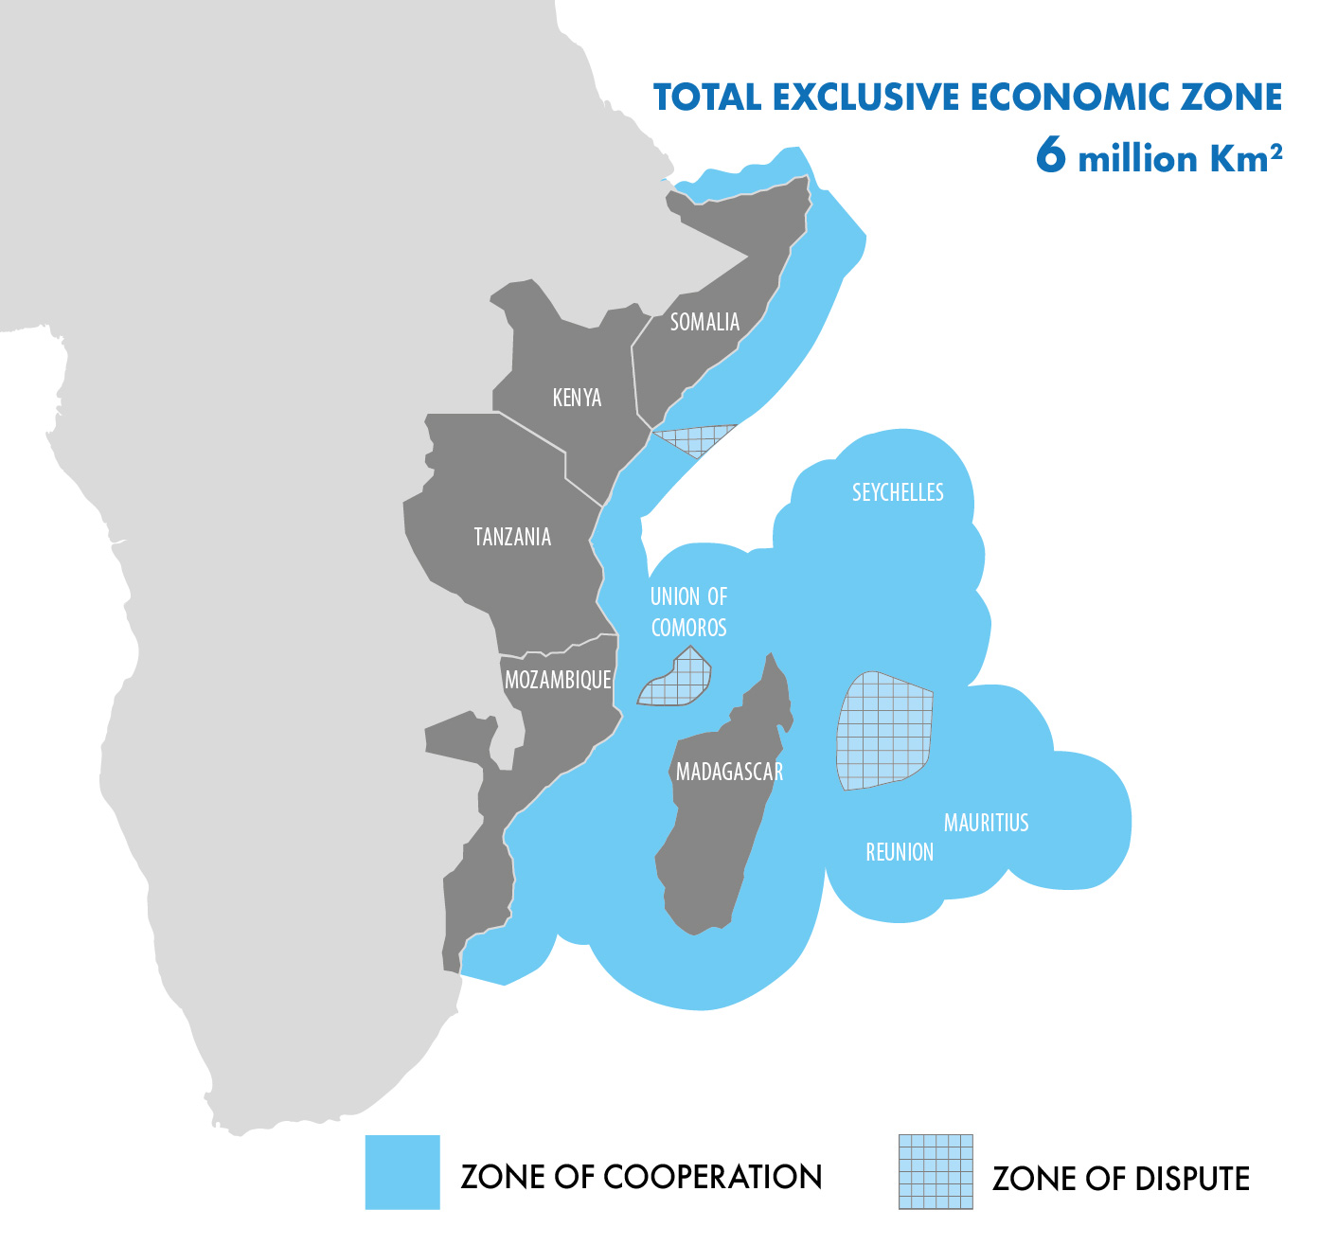

ANNEX II

DATA TO BE EXCHANGED

Parties shall exchange the following data in accordance with this Agreement.

- Satellite based tracking and monitoring information;
- Electronic Monitoring System (EMS) data;
- EEZ Entry / exit reports;
- Innocent passage in EEZ;
- Inspection reports at sea and in port;
- Sighting information;
- Observation details;
- Flagged vessel registration details;
- Management of violations;
- Licensed fishing vessels; and
- any other information that may be approved by the Parties.

ANNEX III

VMS

The draft Memorandum Of Understanding among the participating States of the IOC PRSP for the establishment of a sub-regional satellite based VMS for data sharing and providing for its confidentiality

(To be considered for inclusion as an Annex)

