CONCEPT NOTE
TECHNICAL WORKSHOP ON REGIONAL FRAMEWORK FOR FISHERIES INFORMATION SHARING FOR THE PURPOSE OF MCS
1. INTRODUCTION
Information sharing
The incentive for fishing vessels to operate illegally is a lower cost curve. The fundamental hypothesis behind this is that fishing vessels conducting IUU fishing activities have lower operational costs than those operating legally, for instance through the use of prohibited fishing gears and under reporting/misreporting and in some cases not licenced in coastal states jurisdiction. However, the deterrent is the risk of being detected and fined at a rate proportional to the value of the catch or profits obtained. Most countries have fishing port and authorised enforcement officers that patrol their jurisdictions on the look-out for possible IUU fishing. A country’s authorized enforcement officers undertake a variety of MCS actions for physical inspection on patrol boats, Port States measures inspections to satellite remote sensing. When an enforcement agent detects an instance of a possible IUU fishing activity, they can inform their home port about which fishing vessel was conducting the illicit act, allowing for the appropriate follow up and penalty to be imposed when that fishing vessel returns to port to land its catch. In the event that the vessel of foreign vessel inform the relevant Regional Fisheries Management organisation (RFMO) for IUU listing and a non RFMO vessel to the FAO.

When it comes to regional context, Information sharing boosts levels of fish stock in a region, even when only one country’s is sharing information. This is because, the coastal states are in essence managing a shared fishery resource, meaning that an increase in the level of fish stock in one country’s waters will eventually filter through into the neighbouring country’s waters through the movements of pelagic fish population.
When there is a one-way flow of information, the greatest beneficiary is the country that is sharing the information, since this directly deters IUU fishing activities by increasing the risks of detection for fishing vessels. This shows that while domestic policies and practices are critical in countering IUU fishing, frameworks that promote information and resource sharing between countries represent a powerful and cost-effective tool for supporting shared fisheries. By contrast, the principal beneficiary of information sharing is the party sharing the information, meaning that equilibrium outcomes with high levels of co-operation are feasible and indeed likely if countries are equipped with the technological, operational and legal means to do so.

In the absence of information sharing, fishing vessels are able to conduct IUU fishing activities in one jurisdiction and land their catch in port of a neighbouring country, without any risk of detection. Information sharing allows countries through the FAO Port States Measure Agreement (PSMA) not to land its illegal catch in its port or make use of its port. As a result, the probability of being sanctioned and black listed by RFMOs rises with levels of information sharing, which consequently deters fishing vessels from carrying out IUU fishing.
Information sharing also allow for national and regional risk analysis and MCS planning to counter IUU fishing at national and regional level and improve surveillance cost effectiveness

However, there is a need to have a regional platform and legal framework to facilitate and legitimise fisheries information sharing.

2. BACKGROUND

2.1 The IOC-PRSP Regional Vessel Monitoring System (VMS)

Since March 2014, the IOC member states signed a regional protocol to exchange VMS data through a regional system with the central server located at the IOC headquarters in Ebene city Mauritius. The protocol depicts, how data should be shared and who to share with, the role of participating states and the IOC secretariate, where the central server should be located and includes a confidentiality clause for the shared data. Figure I below define the structure of the regional VMS and Figure II highlight the end visual result that is available to all signatory states.
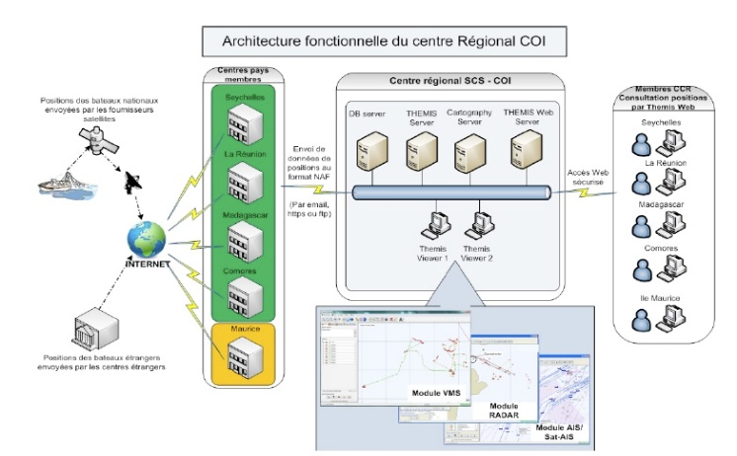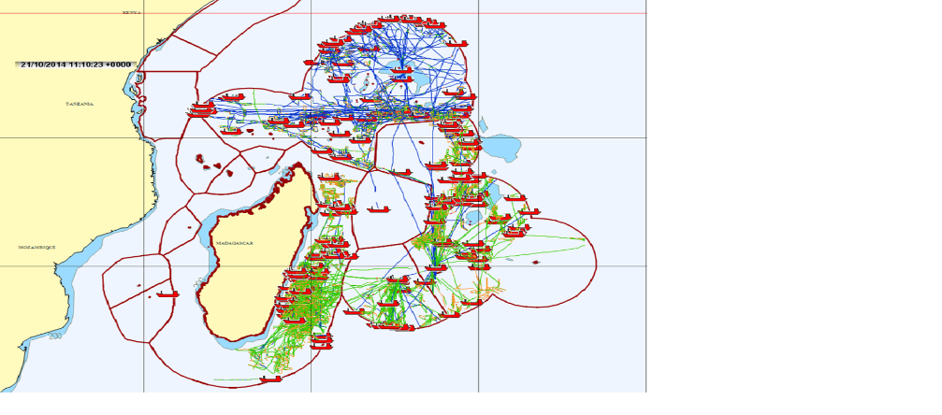
Fig I: Regional VMS structure Fig II: Visual regional VMS data in the zone of cooperation
2.2. The legal context
The basis of sharing VMS data to the IOC regional VMS are the national fisheries legislation of each participating states and the regional protocol established in 2014.
The MOU between the Member States of the Indian Ocean Commission, cooperating for the creation of a Regional Monitoring Scheme for Fishing Activities and Data Sharing and its Confidentiality is the legal document that stipulate how and who may access the data, its management, data confidentiality and role of the states and the IOC secretariat. The present MOU may not necessarily meet today’s regional desires and need. A review of the protocol has been undertaken and approved by the RCU. The review is to guarantee maximum benefit by identifying security or confidentiality gaps as was highly recommended by the 10th ERCU meeting, including parameters that does not meet today’s requirement.

2.3. Other fisheries data

There is no legal basis of sharing other fisheries data in the context of PRSP and this ongoing work to develop a legal framework seek to mitigate this gap and to provide the legal basis.

Other fisheries data that need to be shared in the context of PRSP for day-to-day monitoring of vessel activities and for the purpose of risk analysis are as follows;
- Other Satellite vessel tracking data
- EEZ Entry / exit reports
- Innocent passage in EEZ
- Inspection report at sea and port
- Sighting information
- Vessel Registry: registration no., contact ect….
- Infractions
- List of licensed vessels
- Observer report (Access only within their EEZ)
- Fishing Agent information
- Any other information/data as may be agreed upon by the ERCU.
Most of the above data are to be shared through an established common database (centralised) for the IOC-PRSP with the aim of maintaining of proper record of fisheries information relevant to the PRSP surveillance and observation operations risk analysis and policy decision making at national and regional level. The information shall be used for fisheries management and MCS purposes at national and regional level, notably risk analysis and establish a Module with list of HIGH and MEDIUM risk fishing vessels
The Advantages of having a centralised data-based system for sharing fisheries information are:
- co-operation between countries via the sharing of information and possible and confirm infraction information
- a key element of the Port State Measures Agreement
- can deter and reduce IUU fishing while also boosting the level of biomass in the fisheries.;
- Cumulative enrichment of information;
- Centralise information system;
- List of infractions;
- Unique central Maintenance at lower cost
- Rapid deployment of information
- No compatibility problem (Web based system)
- A necessary tool for risk analysis

The only Constrain is to have a good quality internet connection and dedicated personnel at national level for feeding information in the regional system

2.4 The RCU and decision of the 40th meeting in November 2015
In November 2015, during the 40th RCU meeting in Mombasa, Kenya, it was agreed that the objectives of the existing MOU “between the Member States of the Indian Ocean Commission, cooperating for the creation of a Regional Monitoring Scheme for Fishing Activities and data Sharing and its Confidentiality’’ is too specific to VMS data sharing and does not meet the requirement for sharing other fisheries information. It was agreed that a broader information exchange protocol needs to be defined to ensure that other types of fishery’s information are covered. A draft Protocol was circulated in 2021 for the participating states input and for validated in principle by the 10th Extended Regional Coordination Unit (ERCU) meeting, that was held back-to-back to the 50th RCU meeting.

2.5 The ERCU and decision of the 10th meeting on the 21st October 2011
During the 10th ERCU meeting a draft protocol for fisheries information sharing was presented alongside comment and input provided by the participating states. The ERCU was requested for an agreement in principle relating to the agreement for the sharing of fisheries information for the purpose of MCS
The ERCU welcomed all comment made prior to the RCU meeting by the participating states and discussion and consensus made during the meeting. The ERCU recognized that there is more work to be done inter-sessionally, including a legal workshop as the final stage of developing the protocol. To that effect the ERCU approve the development of the legal framework for fisheries information exchanges for the purpose of fisheries management and MCS, and noted the need for a legal workshop to finalise the protocol, but recommended that the framework should be in the context of an Agreement

3.0 OBJECTIVES OF THE TECHNICAL WORKSHOP
This consultive workshop seek to further develop the information exchange framework with due consideration of comments and inputs from participants as part of the ERCU recommendation. It also aims to inform on amendments made and new inputs by the legal expert in the process of legal scrutinization of the framework.

4.0 RELEVANCE OF THE INTERVENTION
4.1 Relevance and constraints of the action in the EA-SA-IO region
During the 50th RCU meeting in October 2021 in the Seychelles with the exception of article 5, 10 and 11 in the initial draft Agreement, all other articles were technically validated by the RCU. It was recognised that additional work needs to be done with the above mention article.

4.2 Problems to be resolved and the needs to be met
Following the recommendation of the 10th ERCU meeting in Seychelles, the IOC decided to recruit a consultant to assist with finalising the information sharing framework alongside other legal and formal PRSP documents.

11 Annexes

Annex I: Initial Draft agreement on fisheries information sharing agreement and participating states comments

Annex II: First draft of legal expert review

