DRAFT
ADMINISTRATIVE ARRANGEMENT BETWEEN THE INDIAN OCEAN COMMISSION (IOC) AND THE PARTICIPATING STATES OF THE REGIONAL FISHERIES SURVEILLANCE PLAN (PRSP) FOR THE MANAGEMENT AND OPERATIONALISATION OF THE PRSP
PREAMBLE
The Indian Ocean Commission and the Participating States of the Regional Fisheries Surveillance Plan:
RECALLING the rights and responsibilities of coastal States under the 1982 United Nations Convention on the Law of the Sea;
RECALLING the rights and responsibilities of coastal States under the 1995 Agreement for the Implementation of the Provisions of the United Nations Convention on the Law of the Sea of 10 December 1982 relating to the Conservation and Management of Straddling Fish Stocks and Highly Migratory Fish Stocks (UN Fish Stocks Agreement);
ACKNOWLEDGING that the coastal States of the South West Indian Ocean exercise, in accordance with international law, their sovereignty within their internal waters and territorial seas and their sovereign rights for the purpose of exploring, exploiting, conserving and managing the natural resources in their exclusive economic zones;
ACKNOWLEDGING the responsibility of flag States to exercise effective control over their fishing vessels in accordance with international law;
RECALLING the principles of the 1995 Code of Conduct for Responsible Fisheries of the Food and Agriculture Organization of the United Nations (FAO);
RECALLING that at the 2005 Indian Ocean Commission (IOC) Third Summit of the Heads of States, the Member States reiterated the urgent need for regional cooperation not only to achieve better management of the shared fisheries resources, but to fight against illegal, unreported and unregulated (IUU) fishing as well;
RECALLING the 2009 FAO Agreement on Port State Measures to prevent, deter and eliminate IUU fishing (PSMA);
;RECALLING the 1984 Victoria Agreement institutionalizing the Indian Ocean Commission and the 2020 decision of the 34th IOC Council of Ministers adopting the Agreement revising the General Cooperation Agreement between the Member States of the Indian Ocean Commission;
RECALLING the conclusion of the October 2011 meeting of the Extended Regional Coordinating Unit (ERCU) of the PRSP in which the Permanent Liaison Officers of the Indian Ocean Commission member States endorsed the recommendation to enlarge the PRSP activities to neighbouring coastal states;
RECALLING the Declaration and Recommendations of the Fisheries Ministerial Conference signed on 21 July 2017 to Prevent, Deter and Eliminate IUU Fishing in the South-West Indian Ocean;
ACKNOWLEDGING the concerns raised by the Parties regarding the ongoing problem of IUU fishing in the adjacent marine areas, in violation of national and international laws and ageed regional measures;
WHEREAS the cooperation between the Parties is of vital importance for the protection of their national interests in these marine areas;
CONSIDERING the 2014 African Union Policy Framework and Reform Strategy for Fisheries and Aquaculture in Africa;
CONSIDERING the achievements since 2007 of the Regional Action Plan for Fisheries Monitoring Control and Surveillance (MCS) in the Southwest Indian Ocean;
CONSIDERING the Agreement among the Indian Ocean Commission and Participating States on a Regional Fisheries Surveillance Plan for the Establishment of Regional Mechanisms for the Exchange of Fisheries Information for the Purpose of Monitoring Control and Surveillance. which provides a mechanism for cooperation for Participating States and partners to cooperate in the exchange of fisheries information and intelligence to prevent, deter and eliminate IUU fishing;
COMMITTED to building their operational capacity in order to conserve and protect all fisheries resources by undertaking joint and concerted MCS actions;
ACKNOWLEDGING the need to implement international law and promote sub-regional cooperation in order to achieve common goals,
HAVE AGREED as follows:
Article 1
Use of terms

“fisheries information”, or “information” in the context of fisheries activities, includes any information or data in any medium, including electronic, documented, reproduced or other that may be relevant, directly or indirectly, for any purpose of fisheries management or MCS at national, regional or international levels;
“fishing” means searching for, attracting, locating, catching, taking or harvesting fish or any activity which can reasonably be expected to result in the attracting, locating, catching, taking or harvesting of fish;
“fishing related activity” means any operation in support of, or in preparation for, fishing, including the landing, packaging, processing, transhipping or transporting of fish that have not been previously landed at a port, as well as the provisioning of personnel, fuel, gear and other supplies at sea;
“fishing vessel" means any vessel designed or equipped to search for, attract, locate, catch, take or harvest fish or any activity which can reasonably be expected to result in attracting, locating, catching, taking or harvesting fish and includes vessels used for fishing related activities;
”Indian Ocean Commission” (IOC) means the Indian Ocean Commission created in 1982 by the Port-Louis Declaration and established in 1984 by the General Agreement of Victoria;
“inspector” means an officer authorized under the domestic law of a Party to perform fisheries monitoring, control or surveillance operations and report to the delegated national competent authority responsible for fisheries MCS;
“maritime area” means the area within the Zones of Cooperation as defined in Annex 1 and areas where flag vessels of the Parties conduct operations for fishing or related activities in areas beyond their national jurisdiction;
“Monitoring Control and Surveillance” (MCS) refers to monitoring, control, surveillance and enforcement of fishing and fishing related activities;
“MCS tools” includes conventional and technological assets and methodologies used nationally for the purpose of fisheries MCS;
“observer” includes any person authorized under national laws and appointed by a Party to board a licensed fishing vessel to monitor the fishing activity in the maritime area concerned, and report to the designated national competent authority responsible for fisheries observers;
“Participating State” refers to a State or regional economic integration organization that signed the 2007 Declaration of the Ministerial Conference for Combating Illegal, Unreported and Unregulated (IUU) Fisheries in the Southwest Indian Ocean, and includes Comoros, France, Mauritius, Madagascar and Seychelles, as members of the Indian Ocean Commission, and the European Commission;
Regional Fisheries Surveillance Plan (PRSP) refers to the sub-regional plan relating to fisheries MCS established at the Indian Ocean Commission in 2007;
“Regional Coordination Unit” (RCU) refers to the Regional Coordination Unit of the Regional Fisheries Surveillance Plan of the Indian Ocean Commission and in which Participating States are members.
Article 2
Responsibility of the Indian Ocean Commission

- The IOC shall be responsible for coordinating the implementation of this arrangement, and shall annually: approve a report on the implementation of the PRSP to be prepared by the RCU and transmit it to the Ministers responsible for fisheries in the Participating States and relevant donors.
- The Council of Ministers shall have the authority to to approve any request to amend the Zone of Cooperation where there is a resolution of any disputed area within the Zone of Cooperation or for such reasons that the IOC and Participating States may agree, and shall approve any request to extend the Zone of Cooperation upon accession by a new Participating State.
- The IOC shall make available suitable working space and human capacity for the management and operation of the PRSP, in line with agreed governance and institutional frameworks.
Article 3
Administrative and Competent authorities responsible for combating IUU fishing in the maritime area of the Southwest Indian Ocean

Participating states shall officially notify the IOC of their respective competent authorities that have the responsibility for fisheries MCS, and such authorities shall be listed in Annex 2.
Article 4
Objective

The objectives of this Arrangement are to develop and maintain:
- the rapid and regular exchange of fisheries information for the purpose of fisheries management and MCS;

- information on national MCS activities, available surveillance assets and MCS tools of each participating State;

- the implementation of bilateral or multilateral observation and surveillance activities;
- new methods for collecting and sharing information on the activities of fishing vessels;

- joint training of MCS personnel.

Article 5
Administration and financing

- The Regional Coordination Unit shall plan and coordinate regional activities, and ensure that the Regional Fisheries Surveillance Action Plan shall be complementary to the national MCS plans of each Party.
- /the Parties shall develop an agreed Regional Action Plan for MCS activities.
- The beneficiary shall, at the end of each PRSP annual Regional Action Plan, each Participating State shall, inform the IOC of the national actions undertaken during the previous year and the plans for the following year, together with the budget for each.
Article 6
Sub-regional cooperative observation missions

- Sub-regional cooperative observation missions may be undertaken for the purpose of sharing and optimization of the observation assets of two or more Participating States.
- Sub-regional cooperative observation measures shall be subject to a prior Memorandum of Understanding agreed between the Participating States,, which shall require the:
  - observers concerned to continue to report to their designated national competent authority; and
  - the designated national competent authority of the observer to be responsible for channelling the observer report and information to the competent authority or authorities benefiting from a specific mission, in accordance with requirements of any applicable sub-regional MOU for the sharing of observers and observer data.

- The Working Group of Southwest Indian Ocean coastal States National Observer Programme Managers (WG NOPm SWIO) shall be responsible, inter alia, for coordinating sub-regional observation missions, in accordance with its Terms of Reference. The list of National Observer Programme Managers is in Annex 3.
Article 7
Procedures for implementation of Articles 5 and 6

The Enlarged RCU may agree on implementation procedures for Articles 5 and 6, which shall be binding on the Parties.
Article 8
Sub-regional cooperative surveillance missions

- Sub-regional cooperative surveillance missions may be undertaken for the purpose of allowing the sharing and optimization of the sea or air surveillance assets and inspectors of two or more Participating States, thereby promoting the surveillance mechanism as part of the Fisheries Monitoring Plan in the South-West Indian Ocean.
- Sub-regional cooperative surveillance missions shall be subject to a prior Memorandum of Understanding agreed between the Participating States, which shall require the conditions and limits with which assets may be used, and shall include requirements for the:
  - delegated authority to agree to receive the surveillance asset(s) or inspector(s) of one or more other Party;
  - list of air and/or sea assets to be specifically designated.
  - Standard operating procedures
Article 9
Relation to other agreements

Nothing in this Arrangement shall be construed to derogate from the rights and obligations of the Parties under other international agreements to which they are party at the date of signature of this Arrangement.
Article 10
Annexes

- The Annexes form an integral part of this Arrangement.

- Annex 1 is intended as a reference for conducting operational work and nothing in this Arrangement shall be deemed to affect the rights, claims or views of any Party regarding the limits or extent of its fisheries jurisdiction.

Article 11
Procedures for application of this Arrangement to neighbouring countries

The delegated authorities may, by simple agreement between them, in particular within an ERCU meeting, define procedures for applying this administrative arrangement to regional collaboration extended to neighboring countries.
Article 12
Signature and accession

This Arrangement shall be open for signature by the Indian Ocean Commission and all entities defined as Participating States in Article 1.

Article 13
Entry into force

This Arrangement shall enter into force on the date of its signature by the Indian Ocean Commission and all Participating States.
Article 14O
Compliance with this Agreement

Each Party shall take all appropriate measures commensurate with its resources, in accordance with its obligations, and with current international law in order to comply and ensure compliance with this Agreement.
Article 15
Dispute settlement

In the event of doubts or disputes between two or more Parties arising from the interpretation or implementation of this Agreement and/or its Annexes, the Parties shall consult in order to settle the dispute by means of negotiations or any other peaceful means of their choosing.
Article 16
Withdrawal from this Arrangement

Any Participating State may withdraw from this Arrangement may be withdrawn by giving ninety (90) days’ notice of its intention in writing through diplomatic channels to the IOC General Secretariat and all other Parties.
Article 17
Depositary

The original of this Arrangement shall be deposited with the Indian Ocean Commission, which shall serve as the Depositary.
Article 18
Authentic texts

The English and French texts of this Arrangement are equally authentic.

IN WITNESS WHEREOF, the undersigned Ministers, being duly authorized thereto, have signed this Agreement.

OPENED FOR SIGNATURE at xxx, this xxx day of xxx, two thousand two hundred and twenty-three, in a single original, in the English and French languages.

IN WITNESS WHEREOF, THE UNDERSIGNED, being DULY AUTHORIZED BY THEIR RESPECTIVE GOVERNMENT, HAVE SIGNED THIS ARRANGEMENT.

Made on .................., in 3 original copies, in English, these texts being equally authentic.

For The Republic of the Comoros

Date: Name Signature
----------------------------------------------------------------------------------------------------------------------

For The Republic of France (represented by Reunion Island)

Date: Name Signature
----------------------------------------------------------------------------------------------------------------------

For The Republic of Kenya

Date: Name Signature
-------------------------------------------------------------------------------------------------------------

For The Republic of the Madagascar

Date: Name Signature
-----------------------------------------------------------------------------------------------------------------------

For The Republic of the Mauritius

Date : Name Signature
-----------------------------------------------------------------------------------------------------------------------

For The Republic of Mozambique

Date : Name Signature
-----------------------------------------------------------------------------------------------------------------------

For The Republic of Seychelles

Date : Name Signature
-----------------------------------------------------------------------------------------------------------------------

For The United Republic of Tanzania

Date : Name Signature
-----------------------------------------------------------------------------------------------------------------------

For Indian Ocean Commission

Date : Signature
General Secretary of the
Indian Ocean Commission

ANNEX 1
ZONE OF COOPERATION

The Zone of Cooperation includes the official EEZ demarcation of the Participating States and excludes the Zones of Dispute.
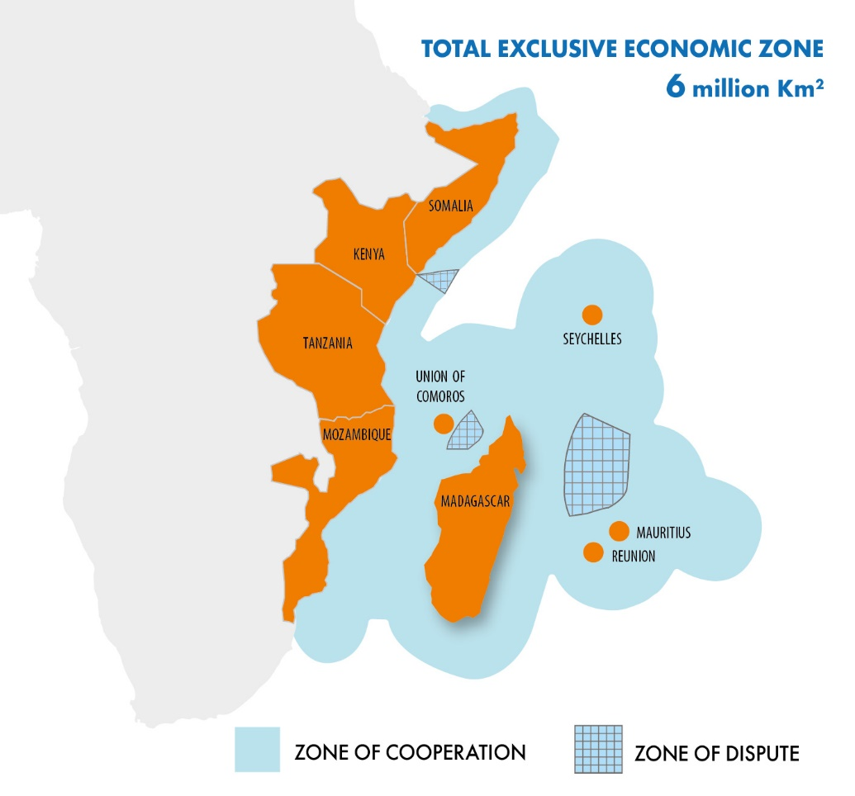

ANNEX 2
LIST OF COMPETENT AUTHORITIES FOR FISHERIES MCS

PARTICIPATING STATES | COMPETENT AUTHORITY FOR MCS
Comoros | National Centre of Fisheries Control and Surveillance (CNCSP)
France/ Reunion | National Fisheries Surveillance Center (CNSP)
Kenya | Kenya Fisheries Service (KeFS)
Madagascar | Fisheries Monitoring Centre (CSP)
Mauritius | Ministry of Blue Economy, Marine Resources, Fisheries and Shipping
Mozambique | Ministry of the Sea, Inland Waters and Fisheries  Directorate National for Operation (DNOP)
Seychelles | Seychelles Fishing Authority (SFA)
Somalia | Ministry of Fisheries and Blue Economy (MFBE)
United republic of Tanzania | Deep Sea Fishing Authority (DSFA)

ANNEX 3

LIST OF COMPETENT AUTHORITIES FOR FISHERIES OBSERVER PROGRAMME

PARTICIPATING STATES | COMPETENT AUTHORITY FOR FISHERIES OBSERVER PROGRAMME
Comoros
France/ Reunion
Kenya
Madagascar | Fisheries Monitoring Centre, Madagascar
Mauritius
Mozambique
Seychelles | Seychelles Fishing Authority (SFA)
Somalia
United republic of Tanzania

